Assisted Practice: 31 Name: Prajwal Diwakar

HTTP Authentication Manager, Cookies, and CSV Set Config.

HTTP Authentication Manager:

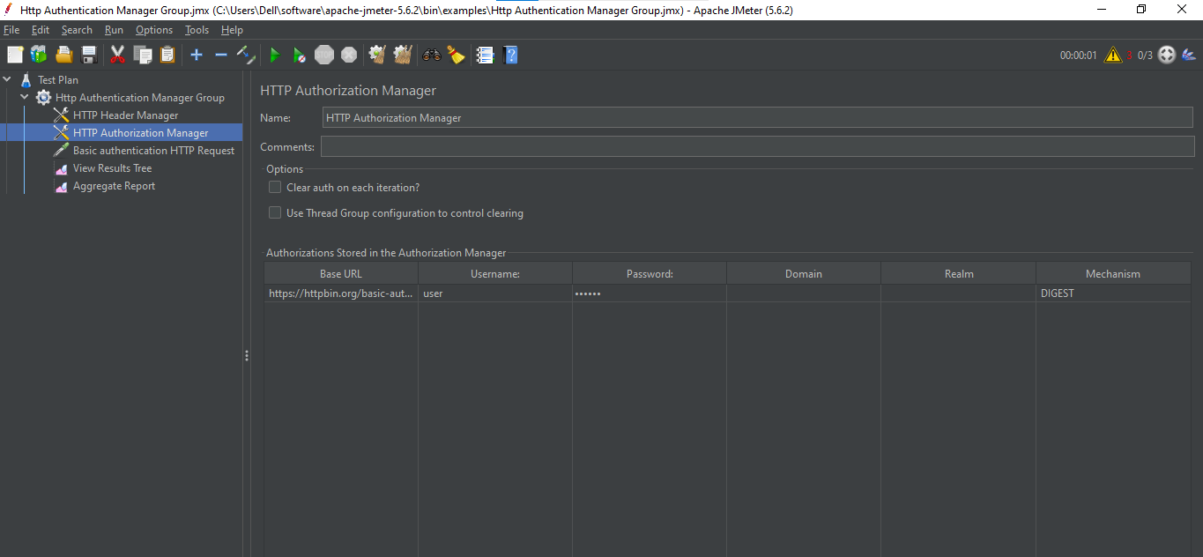

Cookies:

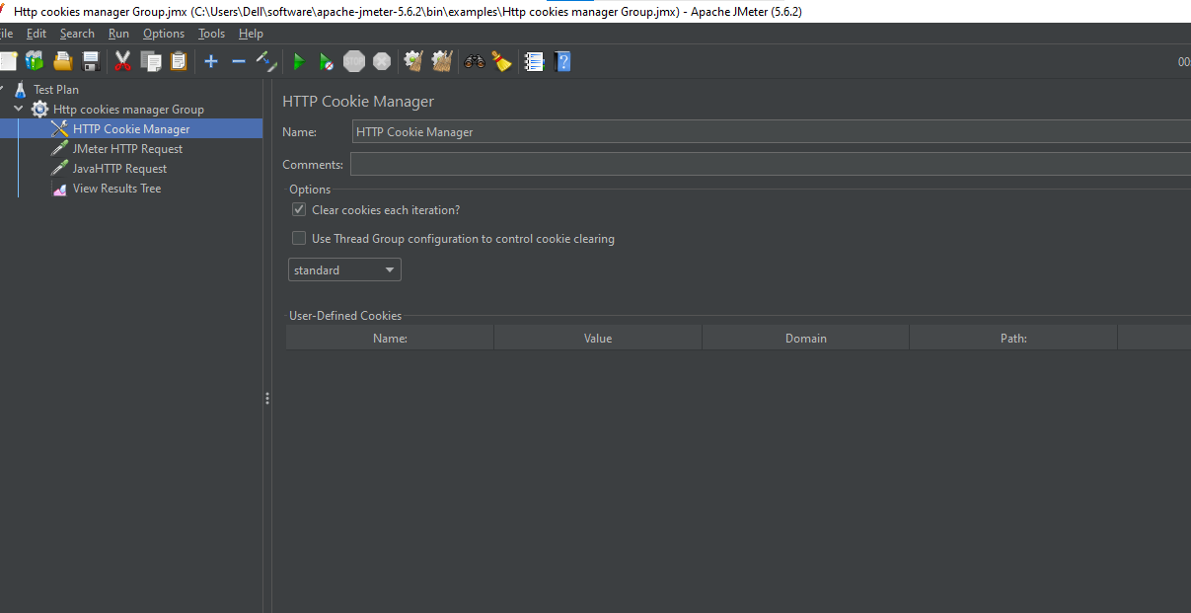

CSV Set Config:

